UNIT 2
FOOD Lesson (Student Tasks)
BNS-1 GEL – 0105 English for Communication and Information Retrieval

Name: _______________________________ Code: _______________ Date: ___/__/___ Group: _______
Task 1:1 Answer the following questions in a complete sentence.
- What food do you like to eat?

- What’s your favorite dish to prepare?

- Do you prepare breakfast, lunch, or dinner?

- Are there any foods that you absolutely won’t eat?

- Who usually does the cooking in your family?

- How often do you eat in a restaurant?

- Can you give me some example of a fast food?

- What is fast food?

- What are the most popular dishes in your country?

- When was the last time you ate at a fast food restaurant?

- Why do so many people eat fast food?

- Which country do you think has the best food?

- Can you think of 10 names different fast food in your country?

- Are there any foods that you absolutely hate?

- Do you think most of your classmates like fast food? And why?

Task 1:2 Fill in the blanks below to complete the sentence. Use the words in the above boxes.

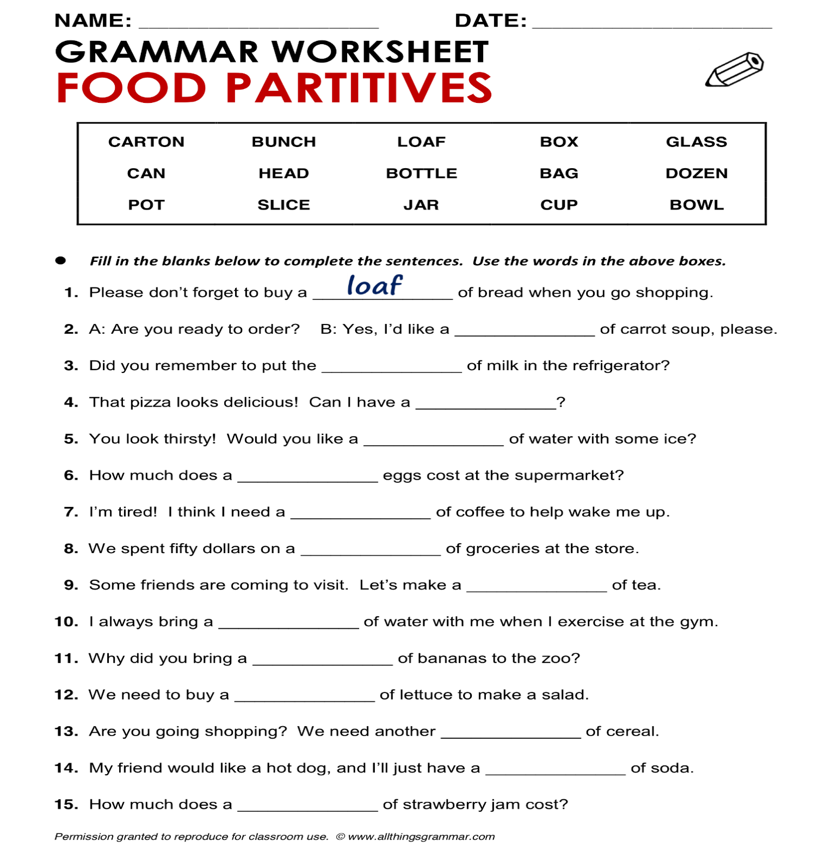
Task 1:3 Multiple Choice. Chose the best answer and write the letter in the box below.
A
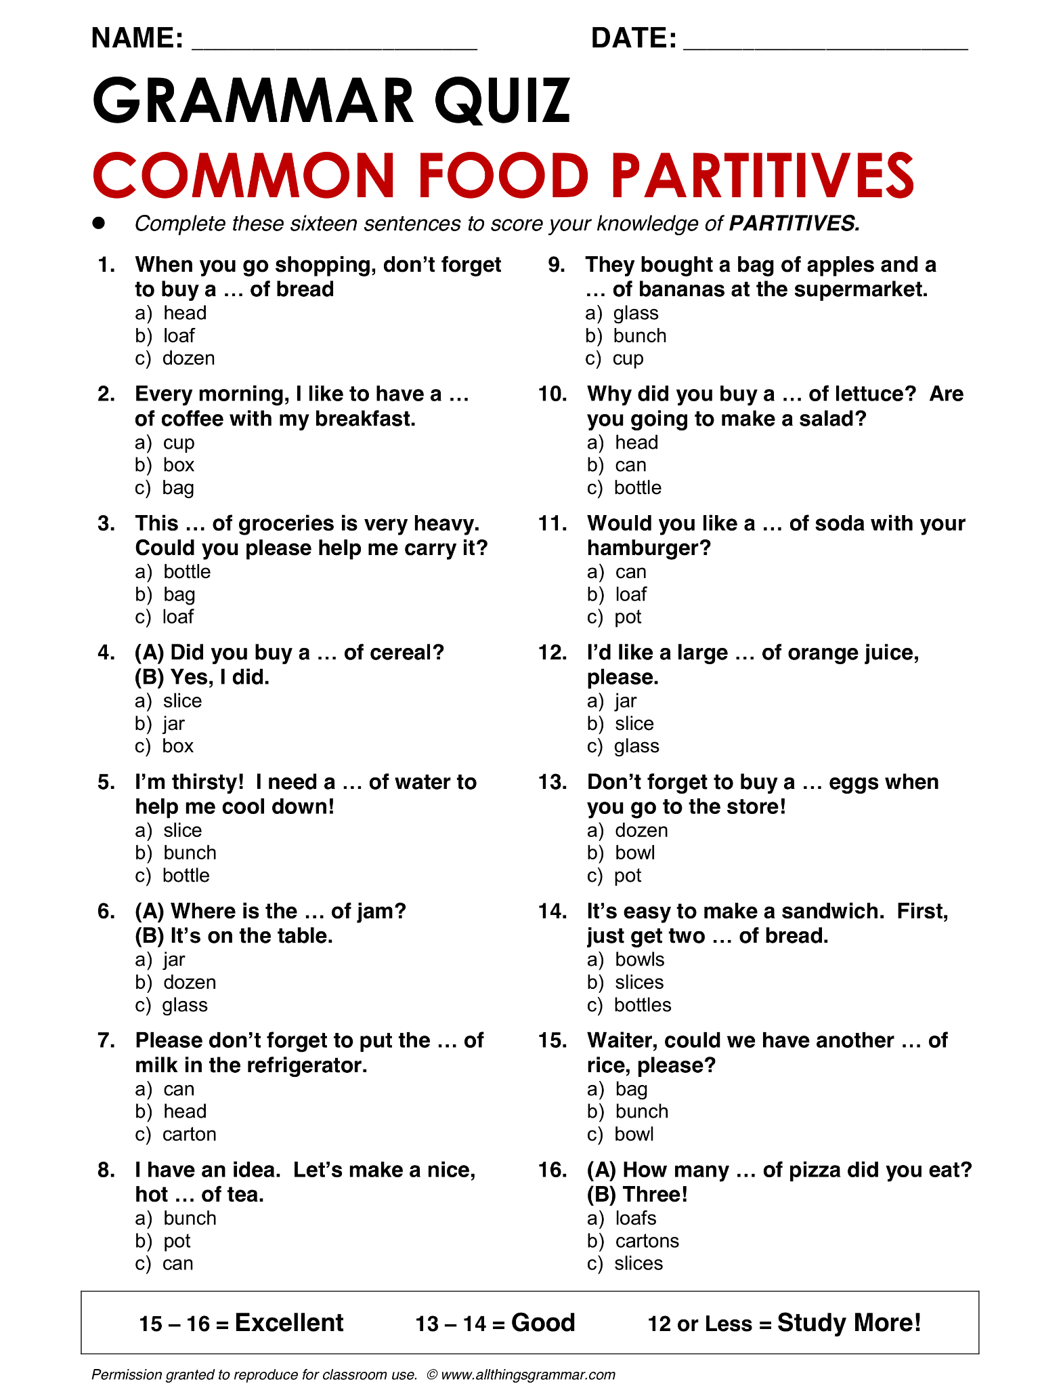
1. | 5. | 9. | 13.
2. | 6. | 10. | 14.
3. | 7. | 11. | 15.
4. | 8. | 12. | 16.
B
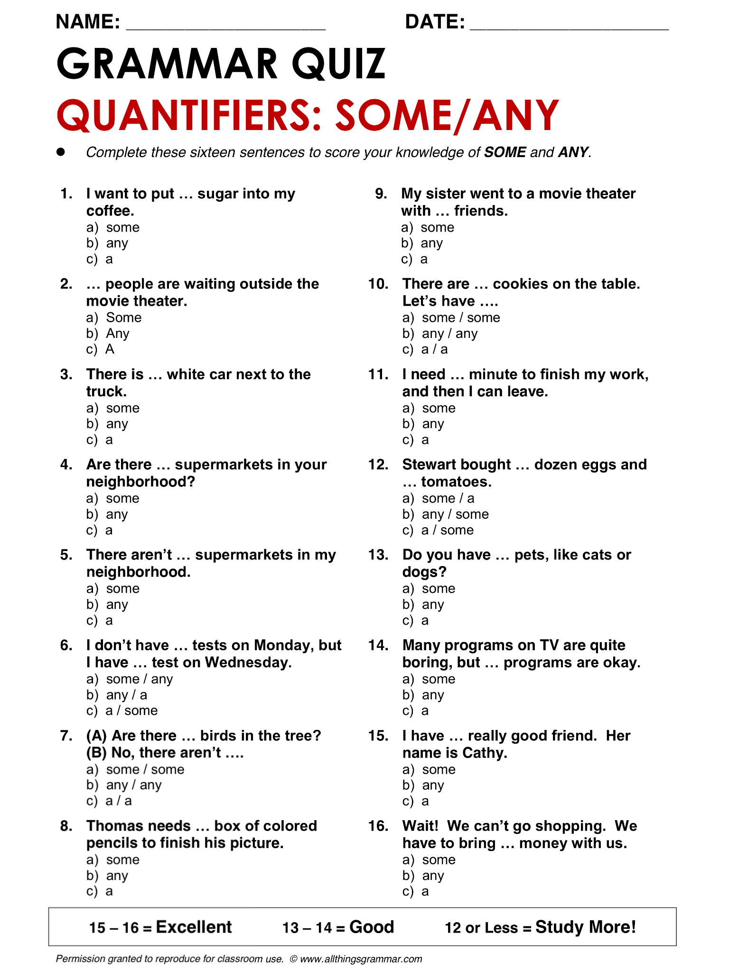
1. | 5. | 9. | 13.
2. | 6. | 10. | 14.
3. | 7. | 11. | 15.
4. | 8. | 12. | 16.
C
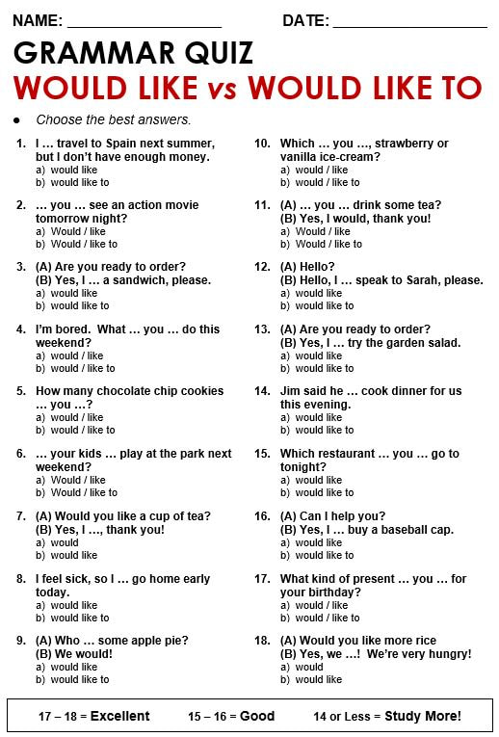
1. | 5. | 9. | 13.
2. | 6. | 10. | 14.
3. | 7. | 11. | 15.
4. | 8. | 12. | 16.

Task 1:4 UNCRAMBLE: Arrange the sentences.
- Would – you – to – eat – some – pizza? – like
_____________________________________________________

- I – never – breakfast – on – have – weekends
_____________________________________________________

- Fruit? – would – you – to – eat – some – like
_____________________________________________________

- Work – I – snacks – eat – at – seldom
_____________________________________________________

- Chicken? – would – you – to – eat – some – like
_____________________________________________________

- Eat – for – pasta – dinner – sometimes
_____________________________________________________

- Bread? Would – you – to – eat – some – like
_____________________________________________________

- Have – I – dinner – with – often – family – my
_____________________________________________________

- Fish? – would – you – to – eat – some – like
_____________________________________________________

- Usually – what – do – you – breakfast? – have –
____________________________________________________

Task 1.5: Fruit and vegetables: Fill in the names of the fruit and vegetables in the picture.
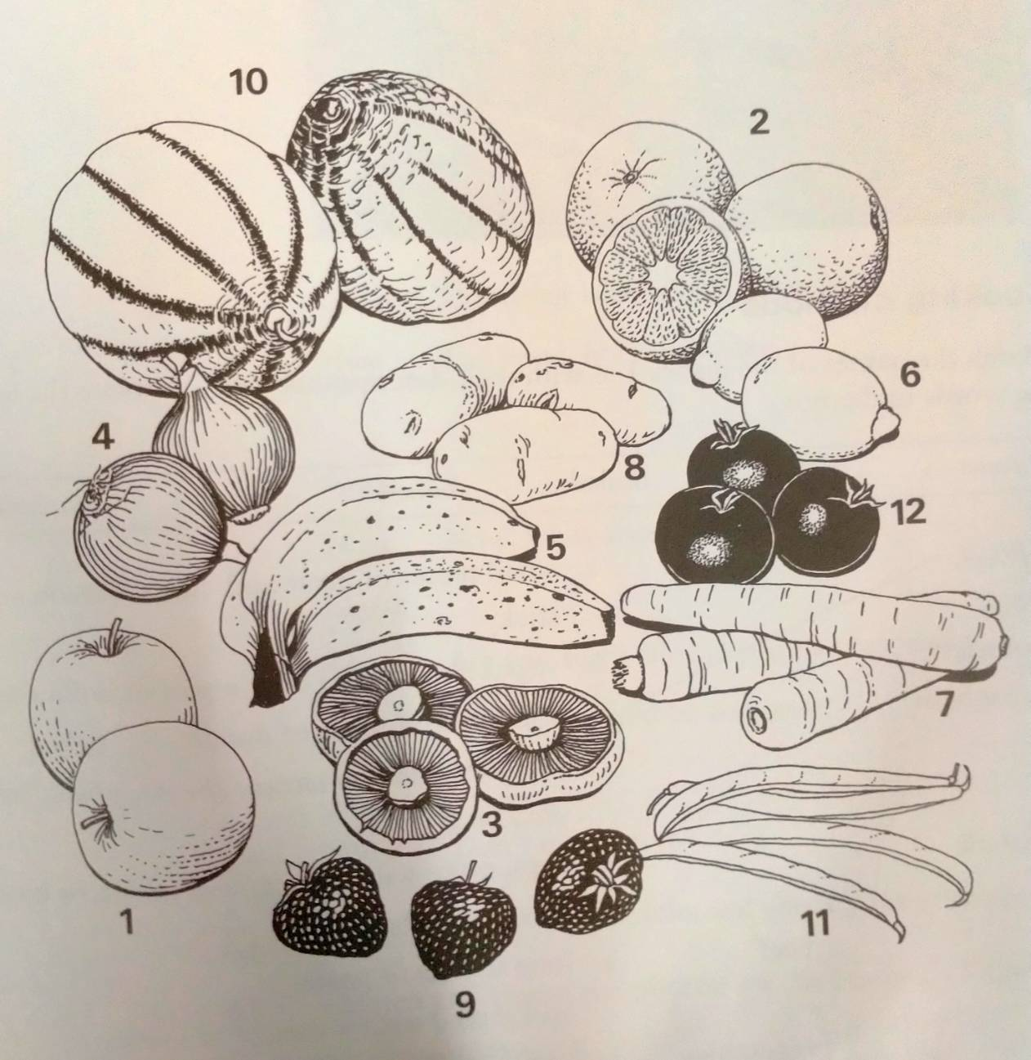
1. _____________________________________
2. _____________________________________
3. _____________________________________
4. _____________________________________
5. _____________________________________
6. _____________________________________
7. _____________________________________
8. _____________________________________
9. _____________________________________
10. ____________________________________
11. ____________________________________
12. _____________________________________

1.6: Food containers: Complete the shopping list for the groceries in the picture. Use the words in the box.
carton packet bag pot tube jar bottle tin

- ________________ of milk.

- ________________ of soup.

- ________________ of spaghetti.

- ________________ of potatoes.

- ________________ of coffee.

- ________________ of olive oil.

- ________________ of jam.

- ________________ of toothpaste.
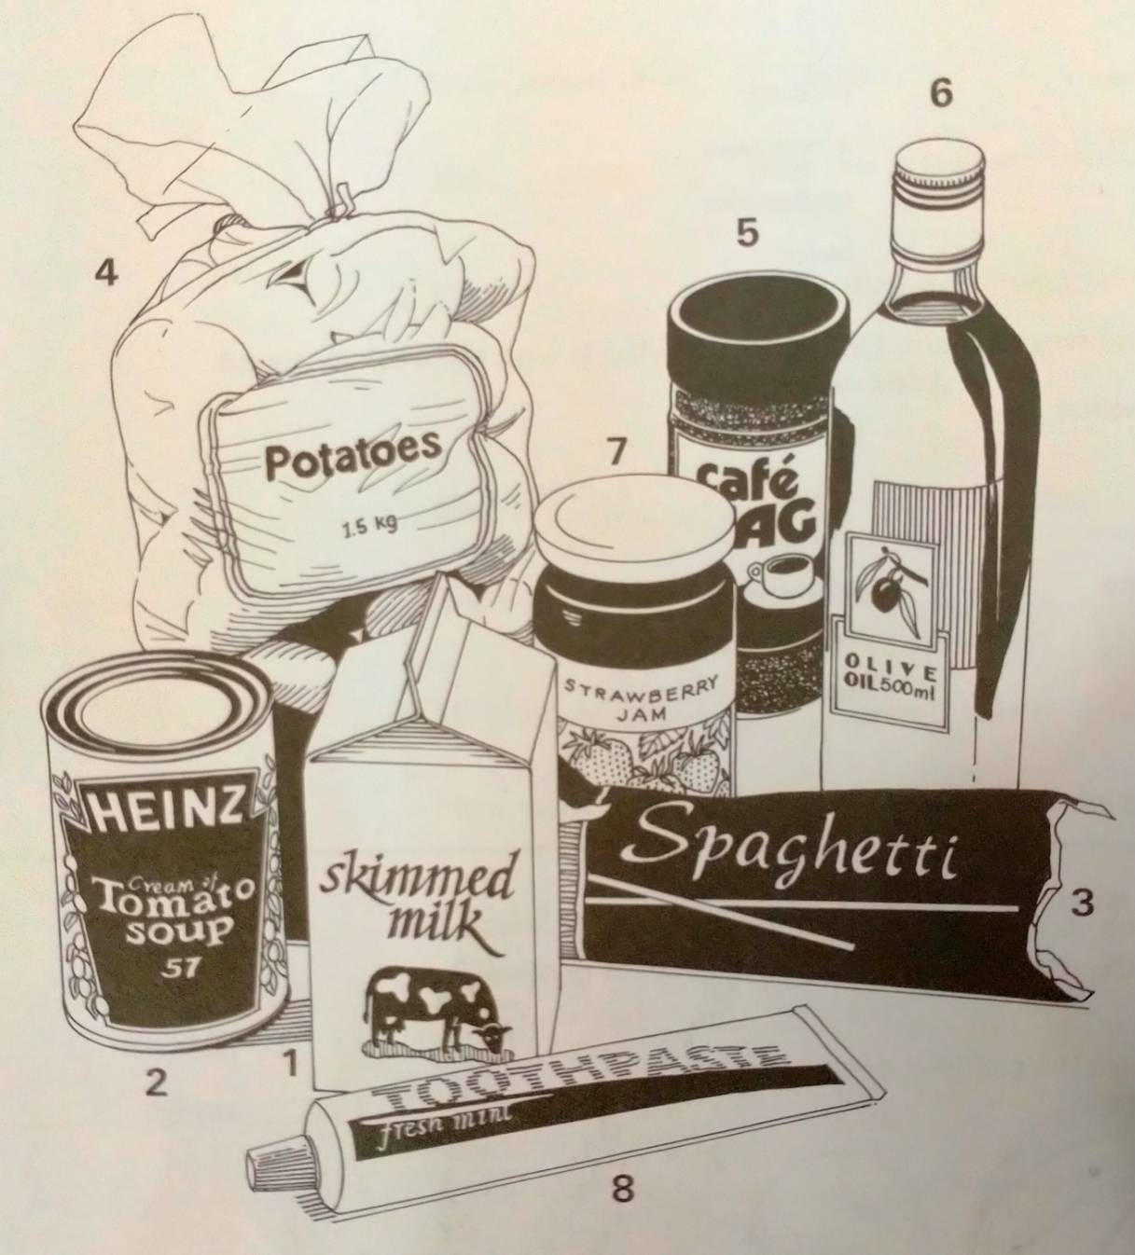

Task 1.7: At the restaurant: Complete the conversation. Use the phrases in the box.
Thank you, but I couldn’t eat any more. How about the main course?
Yes, I’d like to try that. What do you recommend?
Thank you for a really excellent dinner. Would you like some more?
Thanks, just a little.

Host: Let’s order.
Guest: I don’t know anything about Japanese food. (1) _______________________________________.
Host: For the starter, what about chawan mushi?
Guest: Chawan mushi? What’s that?
Host: It’s steamed prawns and vegetables in a thick sauce.
Guest: (2) ________________________________________________________.
Host: (3) _________________________________________________. The tempura is usually very good here.
Guest: What’s tempura?
Host: It’s fried vegetables or king prawns with rice, of course.
Guest: Fine. I’ll have that.
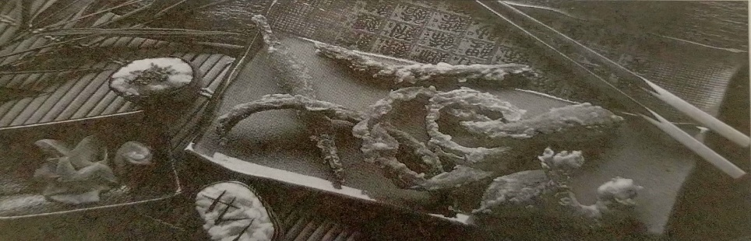
Guest: This drink is delicious. What is it?
Host: Rice wine. It’s called sake. (4) _______________________________________________.
Guest: (5) _________________________________________________________.
Host: Now, what’s about the dessert?
Guest: (6) _______________________________________________________________.
Host: Are you sure? Would you like tea, then?
Guest: Yes, that would be very nice. (7) ___________________________________________________.
Host: Don’t mention it.

